Morton Ranch High School Spring Concert 5-24-16 MRHS PAC
2016 Program Dedications
Program Advertisement Order Form
21000 Franz Road, Katy TX 77449 Director: Renee Gilliland

Date: _____________
Student Name: ___________________________________________
Parent/Sponsor Name: _____________________________________ Phone: (_____) _____-____________
Address: _____________________________________________ City ____________ State _____ Zip __________
Authorized Signature:_____________________________________________________________________________
- Programs will be a half book and ads will be in black and white
Form and payment due by Mon., May 16th by 2:35pm. Ads delivered after that date will not be included in the program. Please submit ad in jpeg format. You can send your order form and ad via email attachment to : ReneeNGilliland@katyisd.org
Pay by cash, money order, or check made payable to MRHSO.

Advertising Size Cost Quantity Total
□ Full Page $25.00 ______ $_________
□ Half Page $15.00 ______ $_________
□ One Line Best Wishes $ 5.00 ______ $_________
Amount Due: $_________
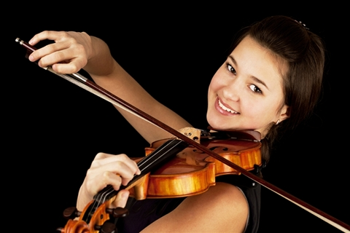
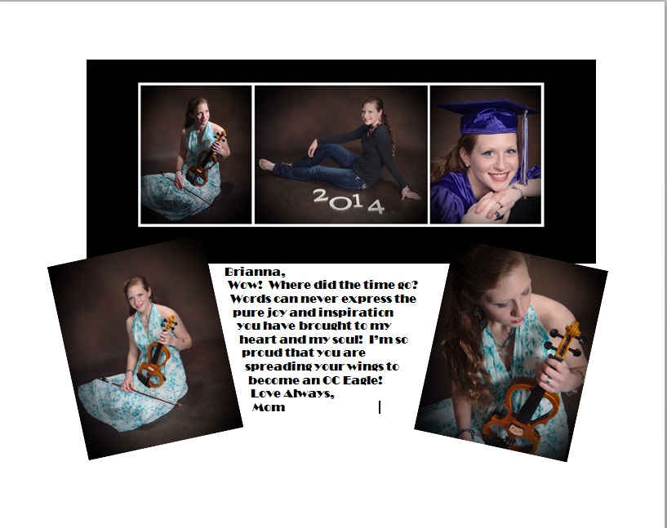

Ashley, we are so proud of you…
Love, Mom & Dad
Congratulations Brianna!! Let your heart, your music, and your strength carry you to the next BIG THING! Love, Your Biggest Fans

MRHSO only: Director/Member: ________________________________________
Amount Paid: $_________ □ Cash □ Money Order □ Check # _________ Receipt #: ________________
Ad Size: □ Full Page □ Half Page □ One Line Best Wishes □ Ad received

